Slack’s GUI

1. Login to Slack’s teamspace using their provided page, for example: <https://kms-technology-inc.slack.com>
2. Open Slack editor by **Settings** > **Team Collaboration** in Katalon studio

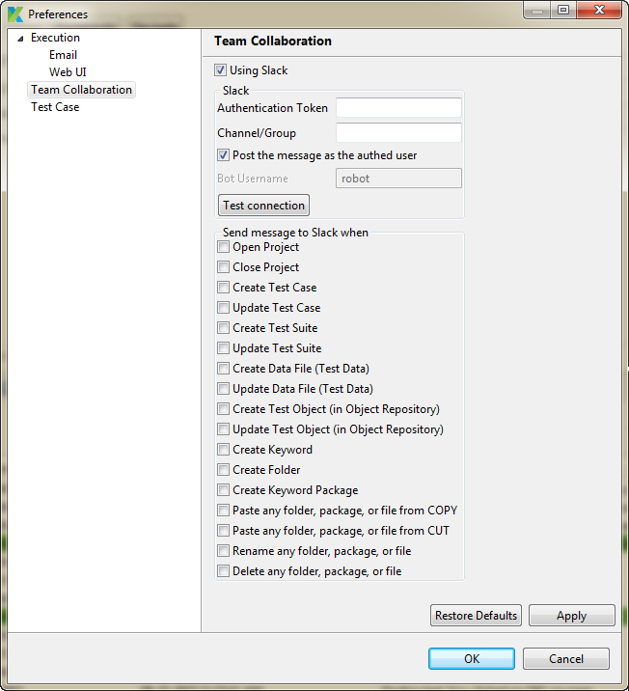

1. Check on **Using Slack** in **Team Collaboration**

You need to get the token’s value from <https://api.slack.com/web> page

Step 1:

Click **Create token** button under **Authentication** group to create your token

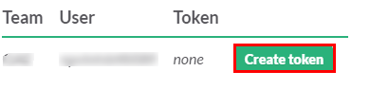

Step 2:

Copy and paste this value for **Authentication Token** textbox in Katalon studio.

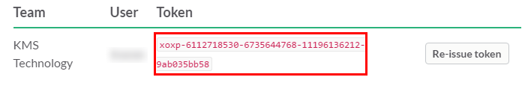

Step 3:

Choose channel or group which user want to chat in Slack page by your name or other name. If you want to use other name, you have to check on **Post the message as the authed user** checkbox

Step 4:

Click **Test connection** button to complete preparation steps.

At the same time, Slack will show the message about connection already made from Katalon to Slack.

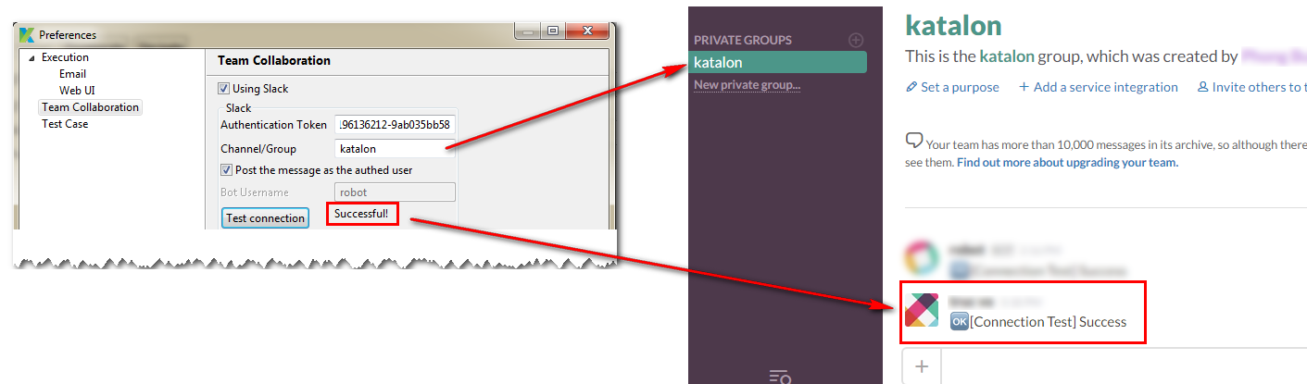

Katalon Studio provided to you the list of supported actions that will be posted to Slack when it happen on Katalon Studio. You just need to check on what actions that you need to post to Slack

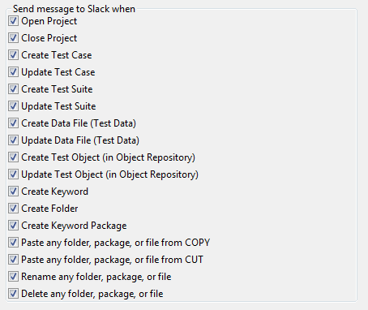

For example:

